ER Forward Run Tutorial: Simulating a Survey and Viewing a Potential Field
In this section we produce a simulated survey arising from a heterogeneous conductivity distribution, and plot the potential distribution simulated for one current source/sink pair. The jupyter notebook ERT2_two_blocks.ipynb takes the user through the steps in this tutorial. The file clear_files.ipynb resets the directory to contain files before running ERT2_two_blocks.ipynb. The directory named visit contains the xdmf potential files created using px, and electrode locations for visualization.
We begin by modifying the homogeneous conductivity distribution from the previous example to that shown in Figure 1. This has been done by changing the conductivity values for each zone in the mesh configuration file (two_blocks.cfg) and rebuilding the mesh. Alternatively, this could be done by manually extracting the zone numbers from the element file (two_blocks.1.ele) and constructing a new conductivity file with conductivity values assigned according to zone. If the first option is used, then the name of the new heterogeneous conductivity file (after mesh reconstruction) is two_blocks.sig. We then execute E4D as before (i.e, mpirun -np 7 e4d), which produces a survey file (two_blocks.sig.srv) that contains the simulated survey for the heterogeneous conductivity distributions shown in Figure 1.

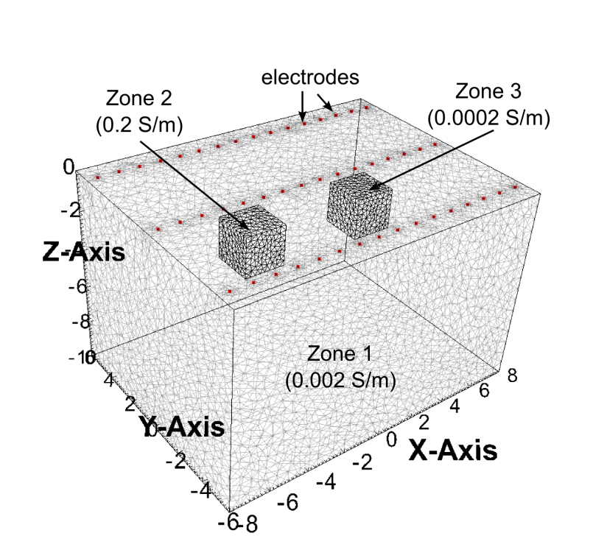
Figure 1. Zones 1-3 of computational mesh and electrode locations with blocks of anamolous conductivity. Zone 4 extends to the outer boundaries and is not shown.
As specified in the output options file, the potential distribution simulated for measurement 1449 is also produced upon execution of E4D and placed in the potential distribution file named potential.1449.
px -f two_blocks potential.1449 pot1449 1449
Figure 2 shows examples of potential distribution plots generated using VisIt. Figure 2.A shows potential isosurfaces for measurement 1449 given a homogeneous conductivity filed of 0.002 S/m, and Figure 2.B shows the corresponding potential isosurfaces for the conductivity distribution shown in Figure 1. It is useful to render the potential distribution in terms of isosurfaces, because current flows parallel to the potential gradient. The isosurfaces therefore indicate the general nature of current flow. For example, the isosurface shown in Figure 2.B indicates the current is directed into the more conductive block (zone 2), and away from the less conductive block (zone 3), in comparison to the homogeneous distribution in Figure 2.A.

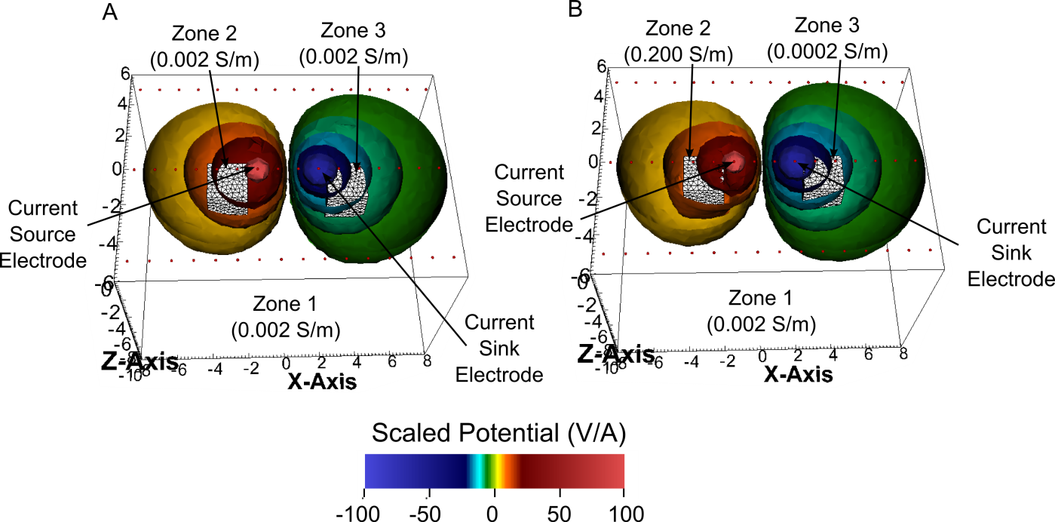
Figure 2. Example numerical potential distributions generated for A) a homogeneous halfspace and B) a heterogeneous halfspace with two blocks of anomalous conductivity.

